2022 AAS-in-Asia Symposium

Cultivating the Humanities and Social Sciences:
Addressing the Multiple Marginalities of South and Southeast Asia

8-10 December 2022
UNISERV, Chiang Mai University, Thailand

Writer’s Talk Event

A discussion about Myanmar society with political writer Min Thayt
and anthropologist Jennifer Leehey

Saturday 10th December 2022
9:00-10:00
Bua Thong Room

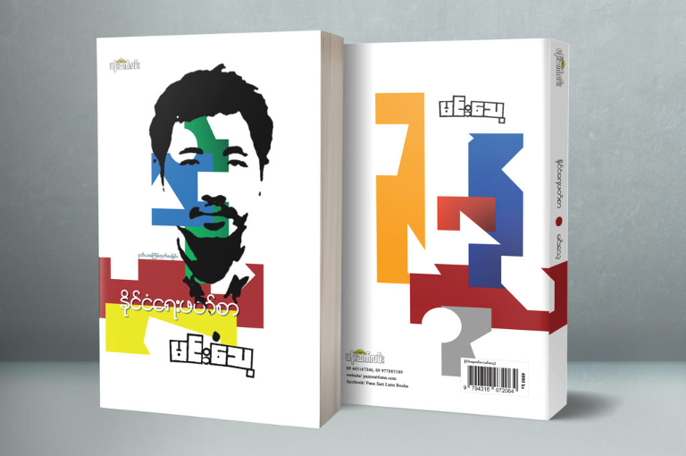

Come to a wide-ranging discussion about Myanmar society, recent history, current political conditions and youth culture, with political writer Min Thayt, in conversation with anthropologist Jennifer Leehey. Min Thayt will discuss his work as a writer, his critical social and cultural commentary, and his perceptions of the current revolutionary moment in Myanmar. The discussion will be in English, with assistance from an interpreter as needed. Audience questions are welcome.

About the participants:

Min Thayt has written opinion articles, evidence-based articles, book reviews and socio- political critical articles for a variety of Myanmar publications, including private journals, magazines, news media and revolutionary bulletins. He published his first book in August 2017, and has now written and published 13 books.

His interest areas are Burman social and political culture and the political history of Myanmar. He received a Master of Political Studies degree from Mandalay University in Myanmar in 2019. His thesis was on “Burmese Nationalism.” He also earned a Diploma in International Relations from Mandalay University in 2014. He was a chief-editor at the University Literature and Culture Association 2011-2012 and librarian at Mya Mandalar Library in 2013. He was co-founder of the Yone Kyi Yar Knowledge Propagation Society and Free Public Library and currently serves on their Board of Directors. Since 2014, he has been a political trainer, working with political parties, civil society organizations, activist groups and student unions and youth on political views. He is currently a research fellow at the Regional Center for Social Science and Sustainable Development (RCSD) at Chiang Mai University

Website: www.minthayt.com
Email: aungkokotoe.minthayt@gmail.com

Dr. Jennifer Leehey received her PhD in sociocultural anthropology from the University of Washington in Seattle, Washington, USA. Her dissertation Open Secrets, Hidden Meanings: Censorship, Esoteric Power and Contested Authority in Urban Burma in the 1990s is a study of everyday life and meaning-making among writers, publishers, poets and cartoonists under the harsh authoritarian conditions of the previous Myanmar military regime, known as the SPDC. She is currently an affiliated researcher at RCSD, Chiang Mai University, and an independent consultant for international development and humanitarian relief organizations.

Email: leeheyj@outlook.com

